Cells Alive- Internet Lesson .............www.cellsalive.com
Objectives: Understand the relative sizes of objects, including the cell, sketch and identify the function of cell structures; compare eukaryote to prokaryote cells; compare plant and animals cells
Part A. "HOW BIG IS A...." (click on the interactive link "howbig" to access this page)
Instructions: Look at the objects that can be found on the head of a pink. Zoom in and out to determine which object is the smallest, then slowly zoom out so you can see how other objects compare.
1. If you zoom all the way in, what is the smallest object on the head of the pin? ______________
Zoom out a little farther, what is the hook shaped object you see? ________________________
2. Compare each of the following objects on the pin, circle the one that is larger.
a) baker's yeast or e. coli
b) lymphocyte or ragweed
c) red blood cell or staphylococcus
d) ragweed or dust mite
3. In the photo below, there is a line that says 200 nanometers. This is used to help you determine how big an object is. It works similar to the way a map works. The line reprents 200 nanometers, but the object itself is bigger.
Use the line to estimate how many lines (200 each) would fit across the object.
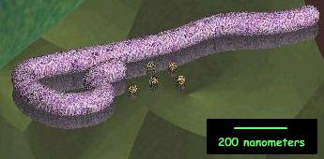
How big is it? ________
Part B: Go to Cell Models and locate the image of a bacterial cell . Label the image below.
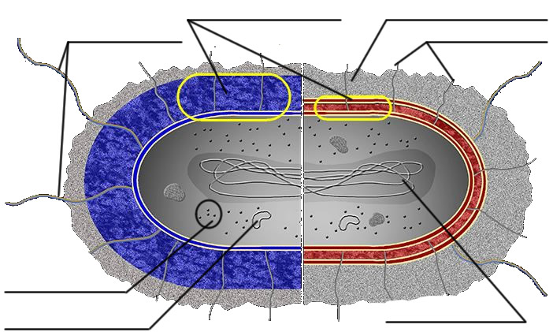
Part C: Go to the Animal Cell Model and click through each of the parts and read their descriptions. Use the information to answer the questions and make sketches of the cell organelles.
Sketches
11. Rough ER

12. Mitochondrion

13. Centrosome

14. Microtubules

1. What do the mitochondrion do?
2. How big are the mitochondrion?
3. What is the function of the golgi apparatus?
4. What structure is found on the rough ER that is not found on the smooth ER?
5. Where is the nucleolus found?
6. What is the function of the nucleolus?
7. What is the function of the cytoskeleton?
8. What within the nucleus is responsible for providing the cell with its unique characteristics?

Go to the Plant Cell Model
9. What structure takes up the majority of the center space within the plant cell? What is its primary function?

10. What part of the plant cell give it is green color? How many of these structure are visible on the plant diagram?
Part D: Comparing Cells
Use what you know about each type of cell (reference pictures if needed), and place a check in the box if the cell has that characteristic or structure.
 | Bacteria | Plant | Animal
Cell Wall
Cell Membrane
Nucleus
Cytosol
Central Vacuole
Chloroplast
Mitochondrion

