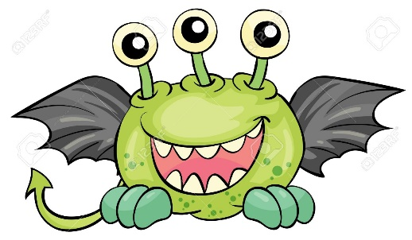
Monster Mash!
Instructions:
Like humans, all monsters share 99.9% of their genetic code identically. So how is it that monsters look so different from one another? That is what this lab will determine while you are making your own baby monster. You will be assigned a mother and father monster and you will have to determine their possible genotypes (there will often be more than one) based on the observable phenotypes. When there could be more than one genotype possible for the parent’s phenotype you will write both possibilities, then flip a penny to decide which genotype the parent will be (circle the genotype that will be used in the cross).
- Basic Mendelian Inheritance
Definition: ______________________________________________________________________________________________________________________________________________________________________
  - Body Shape

Triangle (Dominant, T) or Circle (Recessive t)

    - Mom Genotype(s): Dad Genotype(s):

    - Draw your Punnett Square

    - What are the possible genotypes of the baby monster? What % of offspring will have each phenotypic trait?

    - Draw a number to see what genotype your monster is! Draw that phenotype on the monster page!

  - Ears
Round ears (Dominant R) or Pointed Ears (Recessive r)

    - Mom Genotype(s): Dad Genotype(s):

    - Draw your Punnett Square

    - What are the possible genotypes of the baby monster? What % of offspring will have each phenotypic trait?

    - Draw a number from the class jar to see what genotype your monster is! Draw that phenotype on the monster page! Be sure to return the number to the jar so the probabilities are not altered for each trait.

  - Number of Eyes ** Note: Eye color will be selected in multiple allele section so wait to color in your eyes after drawing the number of eyes on your baby monster**
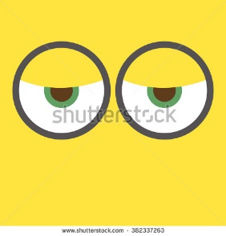
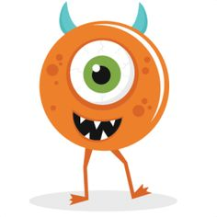
Two Eyes (Dominant, E) or One eye (Recessive, e)

    - Mom Genotype(s): Dad Genotype(s):

    - Draw your Punnett Square

    - What are the possible genotypes of the baby monster? What % of offspring will have each phenotypic trait?

    - Draw a number to see what genotype your monster is! Draw that phenotype on the monster page!
- Incomplete Dominance
Definition: ______________________________________________________________________________________________________________________________________________________
  - Body Color
Dominant allele: B= Red
Recessive Allele: b= Blue
    - Mom Genotype(s): Dad Genotype(s):

    - What is the phenotype of the heterozygous monsters from this incomplete dominance inheritance pattern?

    - Draw your Punnett Square

    - What are the possible genotypes of the baby monster? What % of offspring will have each phenotypic trait?

    - Draw a number to see what genotype your monster is! Draw that phenotype on the monster page!

  - Hair **Note: You will be getting your monster’s hair COLOR in the next section so either draw in black that can be colored, or wait to draw type of hair until you also know your baby monsters hair color**
Dominant Allele: A=tight corkscrew curls
Recessive Allele: a=stick straight hair
    - Mom Genotype(s): Dad Genotype(s):

    - What is the phenotype of the heterozygous monsters from this incomplete dominance inheritance pattern?

    - Draw your Punnett Square

    - What are the possible genotypes of the baby monster? What % of offspring will have each phenotypic trait?

    - Draw a number to see what genotype your monster is! Draw that phenotype on the monster page!

  - Nose
Dominant Allele: N=circle shaped nose
Recessive Allele: n= triangle shaped nose
    - Mom Genotype(s): Dad Genotype(s):

    - Draw your Punnett Square

    - The incomplete dominance pattern for this genetic trait has been thoroughly investigated: heterozygous monsters have a square shaped noses!

    - What are the possible genotypes of the baby monster? What % of offspring will have each phenotypic trait?

    - Draw a number to see what genotype your monster is! Draw that phenotype on the monster page!

- Codominance
Definition: ____________________________________________________________________________________________________________________________________________________________
  - Teeth (round or square)
Q Allele= Square teeth
q allele= Round teeth
    - Mom Genotype(s): Dad Genotype(s):

    - Draw your Punnett Square

    - What are the possible genotypes of the baby monster? What % of offspring will have each phenotypic trait?

    - Draw a number to see what genotype your monster is! Draw that phenotype on the monster page!

  - Hair Color
D allele= Orange Hair
d allele= Black Hair
    - Mom Genotype(s): Dad Genotype(s):

    - Draw your Punnett Square

    - What are the possible genotypes of the baby monster? What % of offspring will have each phenotypic trait?

    - Draw a number to see what genotype your monster is! Draw that phenotype on the monster page!

- Multiple Alleles
Definition: ____________________________________________________________________________________________________________________________________________________________
  - Wings
There are 3 alleles for dragon wings, any dragon can have any two of the alleles, which means there are many phenotypes for dragon wings. The alleles are as follows
W^A= Long Wings
W^B= Talon on the end of wing
W^C= Spikes on wing itself
    - Mom Genotype(s): Dad Genotype(s):

    - Draw your Punnett Square
    - What are the possible genotypes of the baby monster? What phenotype is associated with each possible genotype?

    - Draw a number to see what genotype your monster is! Draw that phenotype on the monster page!

  - Eye Color
There are 4 alleles for eye color in the population of monsters. When more than one allele type is present in an individual monster, the second allele color appears as a ring outside the main eye color (you can choose which color is main, and which is the ring around the outside of the eye).
F^A= Orange
F^B= Neon Green
F^C= Yellow
F^D= Red
    - Mom Genotype(s): Dad Genotype(s):

    - Draw your Punnett Square

    - What are the possible genotypes of the baby monster? What are the phenotypes associated with each of those phenotypes?

    - Draw a number to see what genotype your monster is! Draw that phenotype on the monster page!

- Sex-Linked Inheritance
Definition: ____________________________________________________________________________________________________________________________________________________________
  - Tail
The presence of a tail is known to be on the X chromosome.
    - Mom Genotype(s): Dad Genotype(s):

    - Draw your Punnett Square:

    - What are the possible genotypes of the baby monster? What % of offspring will have each phenotypic trait?

    - Draw a number to see what genotype your monster is! Draw that phenotype (tail or not) on your monster page and record the sex of your baby monster here_________________.

- Challenge: Polygenic Traits
Definition: ____________________________________________________________________________________________________________________________________________________________
  - Fire Breathing
    - Describe how Fire breathing could be a polygenic trait- include how many genes could be involved and the range of phenotypes that you would see in your monster population.

    - Next, choose where in the range of phenotypes your monster baby appears and choose a phenotype for the parents that could support the baby monsters phenotype (2 green fire breathers could not produce a neon pink fire breather for example). Write 2-3 sentences of genetic support how your baby monster’s fire ability exists.

Draw your Monster here!

