Name: _____________________
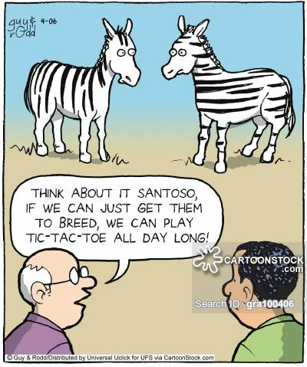
Mutations
Part I. Google “Learn Genetics” and click on first link. Choose the box “Genetic Variation” on the left side. Choose the mutation article on the right titled “What is Mutation?”
- What is a mutation?

- What types of mutations are there?

- How often are mistakes made when copying DNA?

- Why aren’t all of these mistakes kept as mutations in the genome?

- How can mutations be a good thing?

- How does a mutation in the DNA cause a disease?

- Other than mistakes by DNA polymerase, what other things can cause mutations in the genome?

- What is responsible for fixing most mutations?

Part 2. Next go to http://lab.concord.org/embeddable.html#interactives/sam/DNA-to-proteins/4-mutations.json This online activity will allow you to make mutations to a known DNA sequence. Before making any mutations, click on the “show protein” button and jot down some notes on how the protein should look (including the amino acid sequence). Pay attention to how and where the chain of amino acids bend. **Sketch the line for each**
Normal Protein Notes:

Next, make some mutations by clicking on a nitrogenous base and selecting which mutation you would like to see. Note how each mutation effects the proteins amino acid sequence and overall shape and answer the questions. *Remember to reset your DNA sequence between each mutation!*
Task 1: Substitution Mutations
- How does the protein change when you do a single substitution mutation?

- How do you think this effects the protein function overall?

Task 2: Insertion Mutations (Frameshift)
- How does the protein change when you have a single insertion mutation?

- What happens when you inset 3 bases total?

- Which do you think would be worse for the organism and why?

Task 3: Deletion Mutations (Frameshift)
- How does the protein change when you have a single deletion mutation?

- What happens to the protein when you delete 3 bases?

- Which do you think would be worse for the organism and why?

Extension: When you finish the above work, use your chrome book to research other beneficial mutations that have occurred and how they help the organism survive. You don’t have to stay with humans, see how dogs, horses, or sea amenities have mutated over time to better survive their environment!

