Organic molecules Name Period
- Compounds containing the element ______________(C)
- Usually associated with ____________things
- Other elements commonly found in _________molecules:
___________ (H) ____________ (O) _______________N)_____________Phosphorus (P)______________Sulfur (S)
4 main groups of organic molecules
1. Carbohydrates 2. 3. Proteins 4.
Organic molecules are most often considered “macromolecules” macro =

- Monomers join together in a reaction called “dehydration synthesis”. (dehydration = water loss) (synthesize = combine)
-So when larger molecules are formed is
- The opposite of synthesis is called “ ” (requires water)
- Some organic molecules, like lipids, are said to be they will not mix with water
- Other organic molecules are they mix with water
Carbohydrates: Made of ONLY Carbon, , and
Sugars -
-Monosaccharides= “single sugars” (ex- )
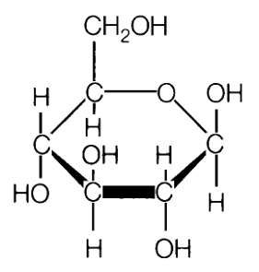
-Disaccharides= “ sugars” (ex.- sucrose, table sugar)
Sugars are for energy
Starch (plants) and Glycogen (animals)-
-Polysaccharides= “ sugars”
Stored Energy (broken down into sugars later
Glycogen is stored in the . Starch is stored in , grains and

Cellulose- Found ONLY in
-Structural (makes plants rigid)
-Indigestible by (“fiber”)
Lipids : Made of: _________________________________________________________________
- Fats and Oils
- energy storage
-Made of 1 molecule & 3 fatty acid -- Triglycerides
- Waxes are repellent
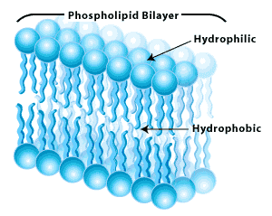
- Phospholipids - membranes
- Steroid hormones
- -chemical control of some body functions
- -made from

Proteins: Made of:_______________________________
- over the dry weight of your body
- VERY with complex 3-dimensional structures
- made of combinations of 20 different acids
  - perform MANY functions:
    - Movement )
    - Structure ( )
    - Chemical Regulation ( )
    - Defense ( )
    - Transport ( )
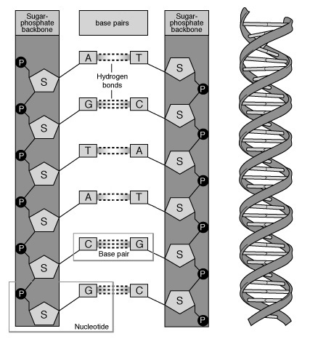
    - Nutrition
Nucleic Acids Made of___________________________________________
Made of units called nucleotide
1. DNA- forms the code (codes for proteins)
2. RNA- vital part of building process
