Name ___________________
Period ____
The Chemistry of Proteins
Introduction
All living things are composed of many different kinds of chemical molecules. One important chemical molecule is protein. Proteins form part of almost all structures within a cell. Therefore, they are essential for cell growth and repair. Also, many proteins are enzymes and are involved in cellular chemical reactions. Proteins are complex molecules made up of simpler building blocks called amino acids. There are 20 different amino acids in nature. The order of amino acids in each protein is coded by a single gene. 1 gene codes for one protein.

Standard: H1L1 Compare and contrast the four types of organic macromolecules. Explain how they comes the cellular structure of the organisms and are involved in critical cellular processes.

Objectives:
- Identify the structure of amino acids.
- Demonstrate the bonding of molecules forms an organic macromolecule.
- Compare and contrast lipids and proteins.
Materials: Scissors, Colored Pencils, Cut Out Sheet

Examine the structural formulas of 4 amino acids shown here.
Glycine Valine Alanine Threonine
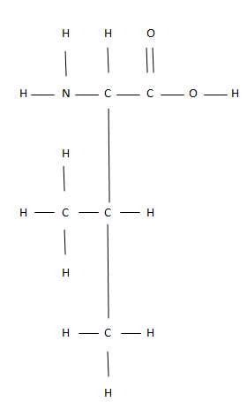
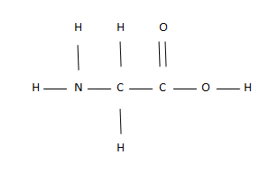
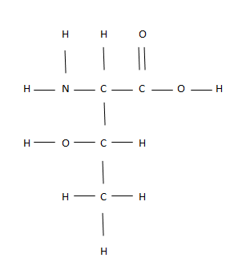
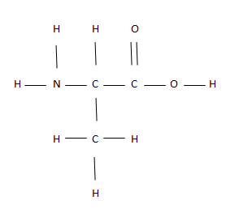

- Which element do amino acids have that lipids and carbohydrates don’t have?

- Write the molecular formula for each amino acid. How are they similar?

- How are amino acids similar to fatty acids?

- Amino acids have a Nitrogen atom and 2 hydrogen atoms. This combination is called an amino group. Circle the amino group in each amino acid.

Bonding Amino Acids to for Proteins
Cut out the 4 amino acid models on the solid lines only.
- How can you connect these pieces to fit together like a puzzle?

Remove OH and H groups as needed so that the pieces connect like a puzzle. Join the models together on a separate shee in this order*: Valine—Threonine—Alanine—Glycine
*You can do this just once with a partner. If it’s not stapled to your paper write down who your partner was:________________
- What is the name of the molecule formed when H and OH are bonded together? How many of these molecules were formed?
Summary Questions
- What are the monomers or “building blocks” of a protein?

- List two ways amino acids differ from fatty acids.

- What are some functions of proteins?

- How can there be so much variety in proteins? What makes them all so different?

- What do we call the instructions for building proteins and where are they found?

