Name: _________________________ Period:_______
Translating the Genetic Code
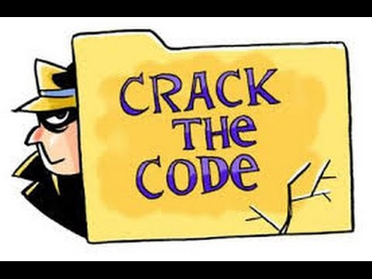
To make a protein we know that DNA is first transcribed to RNA, and the triplets of RNA bases formed in this process (codons) are then translated into specific amino acids in order to build the proteins an organism needs to survive, grow and meet their metabolic needs. A common metaphor for the central dogma is that the bases that make up RNA can be seen as letters, the triplet codons as words and the string of amino acids a sentence.
In this activity you will be doing all the steps of the central dogma: Transcribing DNA into mRNA, moving the mRNA to a ribosome (your desk in this case), and translating the mRNA into the amino acid chain to make up a protein (or in this case the answer to a question).
Procedure:
- Go to the “nucleus” of the cell and transcribe the each of the 5 genes to mRNA. You should copy the DNA sequence as well as the transcribed mRNA (remember to organize it into triplet codon form!)
  - Be careful! Like any good RNA polymerase you should only transcribe the portion of the DNA gene that comes AFTER the promotor! (think TATA)
- Bring your completed mRNA out of the nucleus to the cytoplasm and find a ribosome (desk) to sit at the do the translation process and make your “protein.”
- Translate the mRNA using the code breaking key provided (usually this will tell you which amino acid is in the protein…. Today it will code for a letter in a sentence you are creating).
- Answer the post lab questions.
Gene #1: Think like a proton and…..
DNA: TATTAAAA TAC GCG GGG CGA AGC CTT ACG GCG TGG GGA TGG GAG TCA ATT
mRNA:
Translated Code:

Gene #2: How do you organize a space party?
DNA:
mRNA:
Translated Code:

Gene #3: Two Red Blood Cells fell in love…..
DNA:
mRNA:
Translated Code:

Gene #4: I lost an electron……
DNA:
mRNA:
Translated Code:

Gene #5: Its cold in here!
DNA:
mRNA:
Translated Code:

Post Activity Questions:
- How do 4 nitrogen bases code for 20 amino acids?

- Why is mRNA used in translation of proteins instead of DNA?

- Multiple copies of mRNA can be made at the same time from a DNA template- How is this beneficial for the organism?

- Your little sister/cousin/brother/friend is 5 years old and wants to know how proteins are made. Come up with a metaphor or story that you can use to explain the process of the central dogma in a way that they would understand. (You may not use the letter/word/sentence metaphor at the beginning of this activity).

